**Assignment**

1. **Construct a Simulink model for load frequency control for given data**

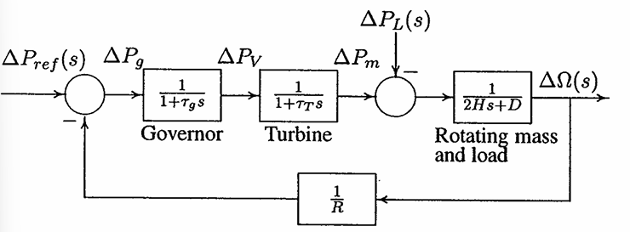

**Fig.- Block diagram of load frequency control**

|  |  |  |  |  |  |
| --- | --- | --- | --- | --- | --- |
| $$τ_{g}$$ | $$τ_{T}$$ | **H** | **D** | **R** | $$∆P_{L}$$ |
| **0.2** | **0.5** | **5** | **0.8** | **0.05** | **0.45 pu** |
| **0.2** | **0.5** | **5** | **0.8** | **0.05** | * 1. **pu** |

**Comment the effect of $∆P_{L}$ variation on Frequency nadir.**